MAHARAJA SURAJMAL INSTITUTE OF TECHNOLOGY

Department of Electronics and Communication Engineering

LAB FILE
SIGNALS & SYSTEMS
(ECC – 259)

Semester 3rd

Submitted By | Submitted To
Rishi Parkash Verma | Dr.
03315002825 | Professor
ECE-1 (3rd Semester) | Department Of

INDEX
Exp no. | Date | Exp name | Page no. | Teacher’s sign | Remarks

Experiment : 1
Linear equation in 1 variable
Code:
#include <stdio.h>

int main() {
float a, b, x;
printf("Equation: ax + b = 0\n");
printf("Enter a and b: ");
scanf("%f %f", &a, &b);
if (a == 0) {
printf("Not a linear equation (a=0).\n");
} else {
x = -b / a;
printf("Solution: x = %.2f\n", x);
}
return 0;
}

Output:

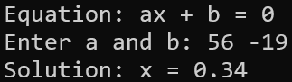

Experiment : 2
Linear equation in 2 variable
Code:
#include <stdio.h>

int main() {
float a1, b1, c1, a2, b2, c2, x, y, det;
printf("Write two Equations in ax + by = c form\n");
printf("Enter a1, b1, c1: ");
scanf("%f %f %f", &a1, &b1, &c1);
printf("Enter a2, b2, c2: ");
scanf("%f %f %f", &a2, &b2, &c2);
printf("Equations are:\n");
printf("%.2fx %c %.2fy = %.2f\n", a1, b1 >= 0 ? '+' : '-', b1 >= 0 ? b1 :
b1, c1);
printf("%.2fx %c %.2fy = %.2f\n", a2, b2 >= 0 ? '+' : '-', b2 >= 0 ? b2 :
b2, c2);
//cramer's rule
det = a1 * b2 - a2 * b1;
if (det == 0) {
printf("No unique solution exists.\n");
} else {
x = (c1 * b2 - c2 * b1) / det;
y = (a1 * c2 - a2 * c1) / det;
printf("Solution: x = %.2f, y = %.2f\n", x, y);
}
return 0;
}

Output:

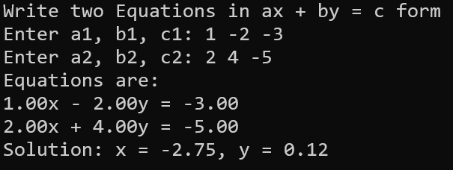

Experiment : 3
Quadratic Equation
Code:
#include <stdio.h>
#include <math.h>

int main() {
float a, b, c, Det, r1, r2, realPart, imagPart;
printf("Equation: ax^2 + bx + c = 0\n");
printf("Enter a, b, c: ");
scanf("%f %f %f", &a, &b, &c);
printf("%.2fx^2 %c %.2fx %c %.2f = 0\n", a,
b >= 0 ? '+' : '-', b >= 0 ? b : -b,
c >= 0 ? '+' : '-', c >= 0 ? c : -c);

Det = b * b - 4 * a * c;

if (Det > 0) {
r1 = (-b + sqrt(Det)) / (2 * a);
r2 = (-b - sqrt(Det)) / (2 * a);
printf("Roots are real and distinct: %.2f and %.2f\n", r1, r2);
} else if (Det == 0) {
r1 = -b / (2 * a);
printf("Roots are real and equal: %.2f and %.2f\n", r1, r1);
} else {
realPart = -b / (2 * a);
if (fabs(realPart) < 0.001)
realPart = 0;
imagPart = fabs(sqrt(-Det) / (2 * a));
printf("Roots are complex: %.2f + %.2fi and %.2f - %.2fi\n", realPart,
imagPart, realPart, imagPart);
}
return 0;
}

Output:
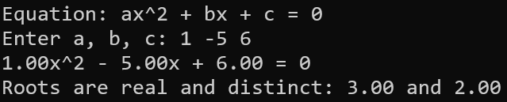
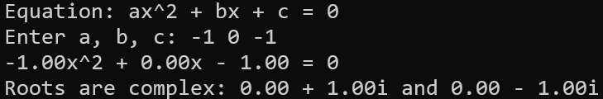

Experiment : 4
Bisection Method
Code:
#include <math.h>
#include <stdio.h>

float A, B, C, D;

float f(float x) {
return ((A * x + B) * x + C) * x + D;
}

int main() {
float a, b, mid, root1, e = 0.000001;
float p, q, r, d, root2, root3;
int iter = 0;

printf("Cubic equation: Ax^3 + Bx^2 + Cx + D = 0\n");
printf("Enter A, B, C, D: ");
if (scanf("%f %f %f %f", &A, &B, &C, &D) != 4 || A == 0) {
printf("Invalid cubic coefficients.\n");
return 1;
}

printf("Enter interval for first root: ");
if (scanf("%f %f", &a, &b) != 2 || f(a) * f(b) > 0) {
printf("Invalid interval\n");
return 1;
}

do {
mid = (a + b) / 2;
iter++;
if (f(a) * f(mid) < 0)
b = mid;
else
a = mid;
} while (fabs(f(mid)) > e);

root1 = mid;
printf("Iterations took %d \n", iter);
printf("First root (bisection): %.6f\n", root1);

p = A;
q = B + A * root1;
r = C + q * root1;
d = q * q - 4 * p * r;

if (d >= 0) {
root2 = (-q + sqrt(d)) / (2 * p);
root3 = (-q - sqrt(d)) / (2 * p);
printf("Second root: %.6f\n", root2);
printf("Third root: %.6f\n", root3);
} else {
float real = -q / (2 * p);
float imag = sqrt(-d) / fabs(2 * p);
printf("Second root: %.6f + %.6fi\n", real, imag);
printf("Third root: %.6f - %.6fi\n", real, imag);
}

return 0;
}

Output:
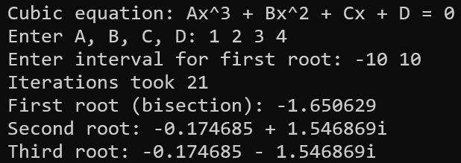

Experiment : 5
Secant Method
Code:
#include <math.h>
#include <stdio.h>

float A, B, C, D;

float f(float x) {
return ((A * x + B) * x + C) * x + D;
}

int main() {
float x0, x1, x2, e = 0.000001;
float p, q, r, d, root2, root3;
int iter = 0;

printf("Cubic equation: Ax^3 + Bx^2 + Cx + D = 0\n");
printf("Enter A, B, C, D: ");
if (scanf("%f %f %f %f", &A, &B, &C, &D) != 4 || A == 0) {
printf("Invalid cubic coefficients.\n");
return 1;
}

printf("Enter initial guesses: ");
if (scanf("%f %f", &x0, &x1) != 2 || (f(x0) - f(x1)) == 0) {
printf("Invalid initial guesses.\n");
return 1;
}

do {
x2 = (f(x1) * x0 - f(x0) * x1) / (f(x1) - f(x0));
iter++;
x0 = x1;
x1 = x2;
} while (fabs(f(x2)) > e);
printf("Iterations took %d \n", iter);
printf("First Root is : %f\n", x2);

p = A;
q = B + A * x2;
r = C + q * x2;
d = q * q - 4 * p * r;

if (d >= 0) {
root2 = (-q + sqrt(d)) / (2 * p);
root3 = (-q - sqrt(d)) / (2 * p);
printf("Second root: %.6f\n", root2);
printf("Third root: %.6f\n", root3);
} else {
float real = -q / (2 * p);
if (fabs(real) < 0.000001)
real = 0;
float imag = sqrt(-d) / fabs(2 * p);
printf("Second root: %.6f + %.6fi\n", real, imag);
printf("Third root: %.6f - %.6fi\n", real, imag);
}

return 0;
}

Output:
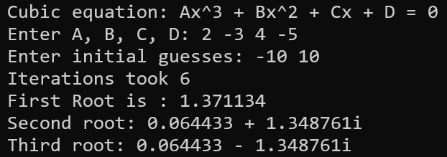

Experiment : 6
Newton Raphson Method
Code:
#include <math.h>
#include <stdio.h>

float A, B, C, D;

float f(float x) {
return ((A * x + B) * x + C) * x + D;
}

float df(float x) {
return (3 * A * x * x) + (2 * B * x) + C;
}

int main() {
float x0, x1, e = 0.000001;
float p, q, r, d, root2, root3;
int iter = 0;

printf("Newton-Raphson Method for Ax^3 + Bx^2 + Cx + D = 0\n");
printf("Enter A, B, C, D: ");
if (scanf("%f %f %f %f", &A, &B, &C, &D) != 4 || A == 0) {
printf("Invalid cubic coefficients.\n");
return 1;
}

printf("Enter initial guess: ");
if (scanf("%f", &x0) != 1) {
printf("Invalid initial guess.\n");
return 1;
}

do {
if (df(x0) == 0) {
printf("Derivative is zero. Cannot continue.\n");
return 1;
}
x1 = x0 - f(x0) / df(x0);
iter++;
x0 = x1;
} while (fabs(f(x1)) > e);

printf("Iterations took %d\n", iter);
printf("First root: %.6f\n", x1);

p = A;
q = B + A * x1;
r = C + q * x1;
d = q * q - 4 * p * r;

if (d >= 0) {
root2 = (-q + sqrt(d)) / (2 * p);
root3 = (-q - sqrt(d)) / (2 * p);
printf("Second root: %.6f\n", root2);
printf("Third root: %.6f\n", root3);
} else {
float real = -q / (2 * p);
if (fabs(real) < e)
real = 0;
float imag = sqrt(-d) / fabs(2 * p);
printf("Second root: %.6f + %.6fi\n", real, imag);
printf("Third root: %.6f - %.6fi\n", real, imag);
}
return 0;
}

Output:
